31 March 2023

Submission for NT ICAC

How to better protect whistleblowers

I would like to start with this comment below. It is from a recent article on the award winning NTIndependent.com.au website.

It sums up perfectly my, other whistleblowers’ (who I know personally) and the public’s opinion about the current state of NT whistleblower ‘protection’ (I use the term very loosely) and the resultant retaliation we/they suffer.

What follows are my opinions based on genuine belief, private and public knowledge. They may sometimes be stated as fact but that failure in editing style is due to my tiredness and weariness of having to plough through this shit one more time while nothing changes.

You have a mountain of work to do to gain any trust whatsoever from employees who it is your job to protect when they report wrongdoing, fraud, nepotism, corruption etc.

***ICAC wants to hear about what happens to Whistleblowers?*** *They know full well what happens to Whistleblowers!!!!!  
Todays NT Whistleblower is tomorrows interstate resident just the way the NT Government wants it!*

*Eff ICAC! What a waste of time. Do not go near these people! If you see Corruption, ask if you can join in!   
Do not think this dysfunctional Government Department wants to hear from you or deal with your complaint!   
In Australia's dodgiest jurisdiction where Companies have to Buy there Government Tenders, ICAC NT has no runs on the board (Minus there own staff being dodgy b@st@rds!)!*

Guidelines and Recommendations are useless, any document or framework must be backed by the law and legal consequences for breach. More importantly, the public and the employers who retaliate, have to see successful prosecutions for retaliation and wrong doing in order for them to believe that they will be held accountable at the first whiff of whistleblower retaliation.

My name is Ferg Ferguson (formerly known as Stephen Ferguson). I was the first official whistleblower against the NT Department of Education before the ICAC was born, to the Office of Public Interest Disclosures (PID), in 2008/2009.

To this day, in 2023, I am still suffering the consequences of that and other disclosures.

What follows are my suggestions for fixing this dilapidated, broken, not fit for purpose system of ‘protection’. Some are within your control, others are not but are provided as food for thought.

1. The ICAC should know how to protect whistleblowers. Seriously, if you don’t know how to do that then you’re in the wrong job. Step aside and give your job to a whistleblower who has lost theirs supporting integrity and honesty in their workplace. Your organisation’s attempts to root it out has failed miserably, so far.

There are a number of links to articles at the end of this submission which help to explain the situation. You really don’t need to hear from us, just read those articles online. This feels like another one of those situations where people think their voices are being heard but nothing actually changes. Very much like Aboriginal deaths in custody since the early 80s, there is now Report Fatigue.

2. Proof of whistleblower retaliation is currently predominately and in reality the responsibility of the poor whistleblower who is already at a major disadvantage. As what happened to me with NTGOV, any employer simply trots out the following when accused of it: yes we exposed them to adverse action but not because of their whistleblowing, it was because of [insert range of pathetic, horseshit reasons-eg sudden accusations of: bullying, performance issues, unprofessional email writing, aggressive eye movements in the staff room etc etc] and yes, I’ve been accused of all of these things AFTER I blew the whistle, exactly the same way the ATO whistleblower was AFTER he blew the whistle and for the guy AFTER he blew the whistle on the Commonwealth Bank of Australia.

The employer should be the one with the heavy burden of proof to show that the whistleblowing had no influence *whatsoever* on their sudden decision making process which ended in the employee losing their job and possibly terminally damaging their career and their mental health.

In fact, to be truly helpful, any new ‘charges’ or allegations from the employer about the whistleblower such as those above, which suddenly appear AFTER someone blows the whistle, should be classed as an automatic retaliation and immediately prosecuted.

3. If the burden of proof for showing whistleblower retaliation is the civil standard: on the balance of probabilities, then why haven’t there been any successful prosecutions at all in the NT? [see no.7] Clearly not enough is being done to help tired, broken, disadvantaged, financially precarious whistleblowers take sustained legal action against their vindictive and petty employers.

4. Following 2. you then must prosecute people: CEs, upper level managers. HR executives, all of the above. They should lose their jobs/suffer the same fate as the person who is blowing the whistle, not the whistleblower.

5. Any Government employee named in whistleblower retaliation cases should not have access to unlimited Government legal funds and backing from SFNT or any other NTGOV outsourced legal firms. That employee needs to pay out of their own pocket, in the same way the now lonely whistleblower has to when defending their position/job in the face or relentless and blatant whistleblowing repercussions [see 2 above]. The same as I had to do: fighting multiple actions and facing at times more than twelve different Crown Solicitors in SA all working for the Government against me while I was mostly self-represented at that time. You have no idea how daunting this can be and how manifestly unfair and unjust this is. The Government uses tax payer money (practically unlimited resources) to grind me into the dirt and I came within a whisker of being bankrupt, both mentally and financially, while they all sipped cappuccinos and stood up in court and parroted Department lies about me. Is it any wonder nobody wants to do this?

Alternatively, give the whistleblowing employee the same access to those legal funds and resources to at least level the playing field on which their legal battle will commence.

This is a **MAJOR** reason why people do not report wrong doing, and there are others which I will alert you to at the end of this submission, which skew any fight in favour of the NTGOV or employer who disputes the allegations.

Actually, this should be the case across all Government Departments nationwide. This would stop, easily, 90% of the workplace bullying and retaliation cases that employees are forced to take to employment tribunals and courts to protect themselves from aggressive and unethical employers/regional directors/senior executives who are always supported by bullying SFNTs and Crown Solicitors etc.

6. Accept that whistleblower retaliation can happen for many years after the whistleblower has stopped working for the employer they blew the whistle on.

NTGOV settled with me in 2013, when I later tried to get another teaching job to help remote Aboriginal students get educated in 2016, I found this in their newest employment portal system. It is the perfect textbook example of being ‘black balled’. Whoever wrote that should have been prosecuted for continued whistleblower retaliation of me. You can imagine the secret job references I was getting from NTGOV too:

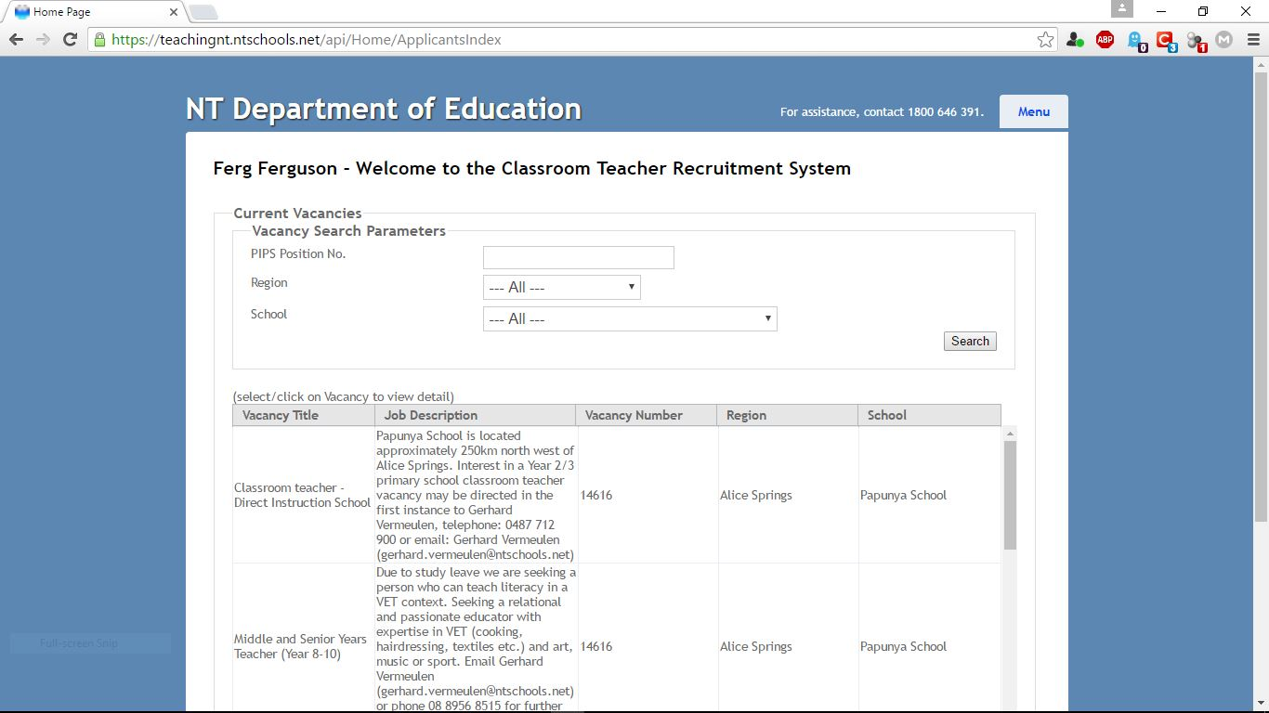

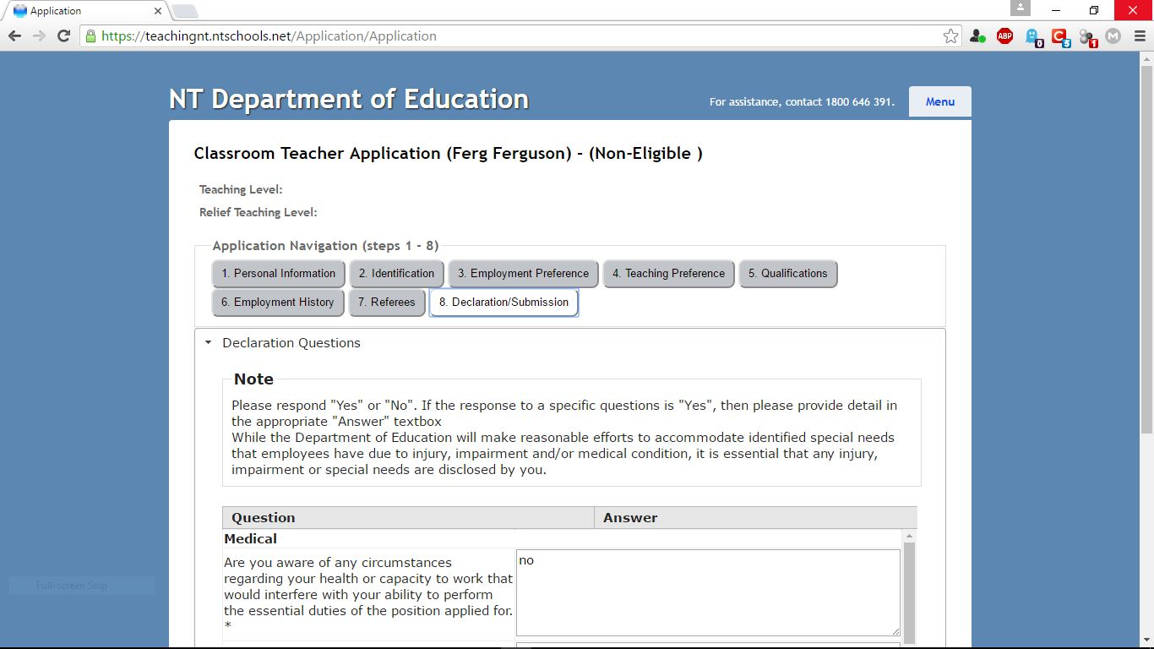

At that time, and still to this day, I have no criminal record, an active Working With Children Card, current teacher registration, multiple positive references of me personally and my work professionally yet I was still deemed ‘non-eligible to teach’, whatever the fuck that means.

They even derailed my application to become a lawyer in the NT, after suffering a brutal and bullying three whole days of cross-examination in the NTSC (this is a whole other level of retaliation that you had to see to believe). I recently read about a case of sexual assault in a school in Australia by a soccer coach. He was cross-examined for two days.

Well, we both know exactly what ‘non-eligible’ means. And if you don’t know now Mr Riches then your willful blindness is contributing to and enabling this continued NTGOV retaliation after I blew the whistle on them.

7. Changing and/or strengthening directions and guidelines for employers of whistleblowers, especially NTGOV, will do absolutely **NOTHING** to protect whistleblowers. If 16 out of 16 NTGOV Public Servants report workplace retaliation for blowing the whistle and that’s published by the ABC and that’s not disputed by **ANYONE** then your system is so broken as to be completely farcical.

## *Key points:*

* *The ICAC reported that 16 of 16 whistleblowers faced reprisals in NT Government workplaces*

8. Mrs Lee Rayner, who is the current head of NT Teacher Registration Disciplinary Actions, is an ex-SFNT. She was the lawyer in charge of defeating my whistleblowing allegations in 2008/2009 and keeping it out of the public arena. She was a horrible bully and a shocking example of how to waste Government money in hunting down whistleblowers like me. Out of frustration I eventually called her boss at SFNT (Meredith Day) one day and demanded to know who was signing the blank cheques given to her and her SFNT friends to try and destroy me. Mrs Rayner left the NT soon after and got a job in Tasmania along with her then partner who was another SFNT, Tim Williams. At one point they worked together officially on my case and tried and failed on a judicial review action in the middle of it. Justice Kelly wrote a scathing decision on that failed review.

Mrs Rayner has now returned to NTGOV, first working in some office somewhere (a Captain’s Pick no doubt) then to the NT Teacher Registration Board, which let’s be honest, behind the facade, is just an arm of the NT Department of Education, there to punish teachers DoE doesn’t like. What better person to run the Disciplinary Section then.

Now cast your mind towards a brave whsitleblowing soul taking on DoE today, with that systemic personnel change staring us all in the face? Waving at us: “Hello everybody, I’m back.”

As if that wasn’t enough, you have Greg Shanahan writing a secret report/review for NTGOV about ICAC and whistleblowing. How do you think that’s going to go for new whistleblowers?

9. Lastly, change the time limit in the current ICAC Act 2017 to include historical cases such as my own, similar to how the rape and sexual assault #MeToo Movement got various statutes of limitations changed to go back many many years in order to hold their many sick perpetrators accountable:

Division 4 Protection from retaliation  
100 Offence to engage in retaliation

…..

(5) A prosecution for an offence against subsection (1) must be started  
within 2 years after the offence is alleged to have been committed.

If it wasn’t so painfully and dangerously pathetic it might actually be a tiny bit funny.

Of course, it is exactly this mess without protection, deliberately. The status quo suits one class of people and punishes another class of people, on purpose.

Some relevant links to online sources are below:

<https://www.theguardian.com/law/2023/mar/31/richard-boyle-to-appeal-after-court-ruled-against-his-whistleblower-status>

<https://www.theguardian.com/law/2023/mar/30/australias-laws-cannot-protect-whistleblowers-like-richard-boyle-court-finds>

<https://www.theguardian.com/australia-news/2023/mar/27/ato-whistleblower-richard-boyle-face-trial-after-immunity-defence-fails>

<https://www.abc.net.au/news/2017-11-30/banking-whistleblower-jeff-morris-tells-of-horrific-impact/9212536>

<https://www.abc.net.au/news/2019-10-23/blowing-the-whistle-on-alleged-wrongdoing-should-not-destroy-you/11627972>

<https://www.abc.net.au/news/2022-06-14/labor-prosecutions-against-whistleblowers-laws-protections/101140464>

<https://www.abc.net.au/news/2019-10-21/icac-nt-whistleblower-protection-northern-territory-government/11620886>

<https://justice.nt.gov.au/law-reform-reviews/published-reports-outcomes-and-historical-consultations/historical/2017/whistleblowerfeedback>